Applecross Senior High School

Semester One Examination, 2019

Question/Answer booklet

MATHEMATICS

SOLUTIONS
SPECIALIST
UNIT 1

Section One:

Calculator-free

Student number: In figures

In words

Your name

Time allowed for this section
Reading time before commencing work: five minutes
Working time: fifty minutes

Materials required/recommended for this section
To be provided by the supervisor
This Question/Answer booklet
Formula sheet

To be provided by the candidate
Standard items: pens (blue/black preferred), pencils (including coloured), sharpener,
correction fluid/tape, eraser, ruler, highlighters

Special items: nil

Important note to candidates
No other items may be taken into the examination room. It is your responsibility to ensure that you do not have any unauthorised material. If you have any unauthorised material with you, hand it to the supervisor before reading any further.

Structure of this paper

Section | Number of questions available | Number of questions to be answered | Working  time (minutes) | Marks available | Percentage of examination
Section One:  Calculator-free | 8 | 8 | 50 | 52 | 35
Section Two:  Calculator-assumed | 13 | 13 | 100 | 98 | 65
 |  |  |  | Total | 100

Instructions to candidates

1. The rules for the conduct of examinations are detailed in the school handbook. Sitting this examination implies that you agree to abide by these rules.

2. Write your answers in this Question/Answer booklet preferably using a blue/black pen.
Do not use erasable or gel pens.

3. You must be careful to confine your answer to the specific question asked and to follow any instructions that are specified to a particular question.

4. Show all your working clearly. Your working should be in sufficient detail to allow your answers to be checked readily and for marks to be awarded for reasoning. Incorrect answers given without supporting reasoning cannot be allocated any marks. For any question or part question worth more than two marks, valid working or justification is required to receive full marks. If you repeat any question, ensure that you cancel the answer you do not wish to have marked.

5. It is recommended that you do not use pencil, except in diagrams.

6. Supplementary pages for planning/continuing your answers to questions are provided at the end of this Question/Answer booklet. If you use these pages to continue an answer, indicate at the original answer where the answer is continued, i.e. give the page number.

7. The Formula sheet is not to be handed in with your Question/Answer booklet.
Section One: Calculator-free 35% (52 Marks)
This section has eight (8) questions. Answer all questions. Write your answers in the spaces provided.

Working time: 50 minutes.

Question 1 (4 marks)
In the diagram below (not drawn to scale) $A, B$ and $C$ lie on the circle with centre $O$ and $OA$ is parallel to $CB$.
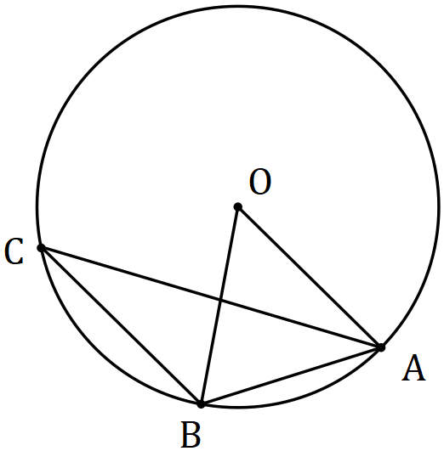

Determine, with reasons, the size of $∠OBA$ and the size of $∠ABC$ when $∠OAC=23°$.
Solution
$$∠ACB=∠OAC=23 \text{(Alternate angles)}$$

$$∠AOB=2×∠ACB=46 \text{(Angle at centre)}$$

$$∠OBA=\left(180-46\right)÷2=67° \text{(Isosceles)}$$

$$∠OBC=∠BOA=46 \text{(Alternate angles)}$$

$$∠ABC=46+67=113°$$

Specific behaviours
$∠ACB$ with reason
✓ $∠AOB$ with reason
✓ $∠OBA$ with reason
✓ $∠ABC$

Question 2 (8 marks)
Let $a=4i-8j$, $b=-3i+6j$ and $c=2i+3j$.

(a) Determine

(i) $b-c$. (1 mark)
Solution
$$\left(\begin{matrix}-3 \\ 6\end{matrix}\right)-\left(\begin{matrix}2 \\ 3\end{matrix}\right)=\left(\begin{matrix}-5 \\ 3\end{matrix}\right)$$

Specific behaviours
correct vector

(ii) $3b+4a$. (2 marks)
Solution
$$3\left(\begin{matrix}-3 \\ 6\end{matrix}\right)+4\left(\begin{matrix}4 \\ -8\end{matrix}\right)=\left(\begin{matrix}-9 \\ 18\end{matrix}\right)+\left(\begin{matrix}16 \\ -32\end{matrix}\right)=\left(\begin{matrix}7 \\ -14\end{matrix}\right)$$

Specific behaviours
determines scalar multiples
correct vector

(iii) $|a+c|$. (2 marks)
Solution
$$\left(\begin{matrix}4 \\ -8\end{matrix}\right)+\left(\begin{matrix}2 \\ 3\end{matrix}\right)=\left(\begin{matrix}6 \\ -5\end{matrix}\right)$$

$$\sqrt{6^{2}+{\left(-5\right)}^{2}}=\sqrt{61}$$

Specific behaviours
determines sum
correct value

(b) Determine a unit vector that is parallel to $a+b$ but in the opposite direction. (3 marks)
Solution
$$-\left(\left(\begin{matrix}4 \\ -8\end{matrix}\right)+\left(\begin{matrix}-3 \\ 6\end{matrix}\right)\right)=\left(\begin{matrix}-1 \\ 2\end{matrix}\right)$$

$$\left|\left(\begin{matrix}-1 \\ 2\end{matrix}\right)\right|=\sqrt{5}$$

$$\text{Soln:}\frac{1}{\sqrt{5}}\left(\begin{matrix}-1 \\ 2\end{matrix}\right)$$

Specific behaviours
determines $-(a+b)$
determines magnitude
correct unit vector

Question 3 (6 marks)
(a) Body $A$ moves $40$ m on a bearing of $315°$. Express this displacement in component form using unit vectors $i$ and $j$. (3 marks)
Solution
$$∠\left(x\text{-axis}\right)=135°$$

$$r=40\cos{135°}i+40\sin{135°}j \\ =-20\sqrt{2}i+20\sqrt{2}j$$

Specific behaviours
correct angle from $x$-axis
✓ correct $i$-coefficient
✓ correct $j$-coefficient

(b) Body $B$ moves with a velocity of $4\sqrt{3}i-4j$ ms⁻¹. Determine the speed of this body and the bearing it is travelling in. (3 marks)
Solution
$$s^{2}={\left(4\sqrt{3}\right)}^{2}+{\left(4\right)}^{2} \\ s=8 \text{m/s}$$

$$∠\left(x\text{-axis}\right)=-30°$$

$$\text{Bearing}=90+30=120°$$

Specific behaviours
✓ correct speed
✓ angle with $x$-axis
✓ correct bearing

Question 4 (7 marks)
Quadrilateral $ABCD$ is shown below. The midpoints of sides $AB, BC, CD$ and $DA$ are $P, Q, R$ and $S$ respectively. Let $\vec{AB}=2b, \vec{AC}=2c$ and $\vec{AD}=2d$.

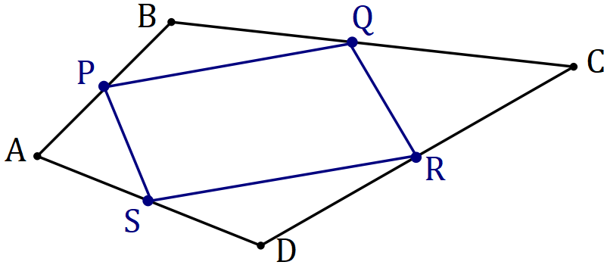
Solution (a)
See diagram
Specific behaviours
correct quadrilateral

(a) Sketch quadrilateral $PQRS$ on the diagram above. (1 mark)

(b) Determine expressions for $\vec{AQ}, \vec{AR}$ and $\vec{QR}$ in terms of $b, c$ and $d$. (3 marks)
Solution
$$\vec{AQ}=2b+\frac{1}{2}\left(2c-2b\right)=c+b$$

$$\vec{AR}=2d+\frac{1}{2}\left(2c-2d\right)=c+d$$

$$\vec{QR}=\vec{QA}+\vec{AR} \\ =\left(-c-b\right)+\left(c+d\right)=d-b$$

Specific behaviours
derives expression for $\vec{AQ}$
derives expression for $\vec{AR}$
derives expression for $\vec{QR}$

(c) Prove that $\vec{PQ}=\vec{SR}$ and $\vec{PS}=\vec{QR}$. (3 marks)
Solution
$$\vec{PS}=\vec{AS}-\vec{AP} \\ =d-b \\ =\vec{QR}$$

$$\vec{PQ}=\vec{AQ}-\vec{AP} \\ = c+b-b \\ =c$$

$$\vec{SR}=\vec{AR}-\vec{AS} \\ =c+d-d \\ =c \\ =\vec{PQ}$$

Specific behaviours
derives expression for $\vec{PS}$ and equates to $\vec{QR}$
✓ derives expression for $\vec{PQ}$
✓ derives expression for $\vec{SR}$ and equates to $\vec{PQ}$

Question 5 (6 marks)
Consider the following statement that refers to two isosceles triangles.

If the triangles have the same area, then the triangles are congruent.

(a) Write the inverse statement and state whether it is true or false. (2 marks)
Solution
If the triangles do not have the same area, then the triangles are not congruent.

This statement is true.
Specific behaviours
correct inverse statement
✓ states true

(b) Write the converse statement and state whether it is true or false. (2 marks)
Solution
If the triangles are congruent, then the triangles have the same area.

This statement is true.
Specific behaviours
correct inverse statement
states true

(c) Write the contrapositive statement and use a counter-example to explain why it is false.
(2 marks)
Solution
If the triangles are not congruent, then the triangles do not have the same area.

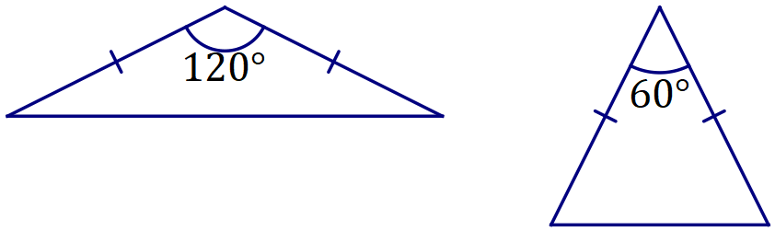
The isosceles triangles shown are not congruent but have the same area.

Specific behaviours
correct contrapositive statement
✓ correct example that uses isosceles triangles
Or ✓ shows dimensions that give same area

Question 6 (7 marks)
(a) The work done, in joules, by a force of $F$ Newtons in changing the displacement of an object by $s$ metres, is given by the scalar product of $F$ and $s$. Determine the work done by

(i) force $F=\left(10i+8j\right)$ N that moves a small body from $\left(2i-8j\right)$ m to $\left(15i+12j\right)$ m.
(2 marks)
Solution
$$\left(\begin{matrix}15 \\ 12\end{matrix}\right)-\left(\begin{matrix}2 \\ -8\end{matrix}\right)=\left(\begin{matrix}13 \\ 20\end{matrix}\right)$$

$$w=\left(\begin{matrix}10 \\ 8\end{matrix}\right)∙\left(\begin{matrix}13 \\ 20\end{matrix}\right)=130+160=290 \text{J}$$

Specific behaviours
displacement vector
✓ correct work done

(ii) a horizontal force of $30$ N that pushes a small body $1.8$ m up a slope inclined at $30°$ to the horizontal. (2 marks)
Solution
$$w=30×1.8×\cos{30} \\ =30×1.8×\frac{\sqrt{3}}{2} \\ =27\sqrt{3} \text{J}$$

Specific behaviours
uses correct expression
✓ correct work done

(b) Determine the vector projection of $\left(2i+4j\right)$ on $\left(-3i+4j\right)$. (3 marks)
Solution
$$\left(\begin{matrix}2 \\ 4\end{matrix}\right)∙\left(\begin{matrix}-3 \\ 4\end{matrix}\right)=10$$

$$\left(\begin{matrix}-3 \\ 4\end{matrix}\right)∙\left(\begin{matrix}-3 \\ 4\end{matrix}\right)=25$$

$$\frac{10}{25}\left(\begin{matrix}-3 \\ 4\end{matrix}\right)=\left(\begin{matrix}{-6}/5 \\ 8/5\end{matrix}\right)$$

Specific behaviours
scalar products
✓ substitutes into expression
✓ correct vector projection

Question 7 (6 marks)
In the diagram below (not drawn to scale), two circles intersect at $F$ and $G$. $AH$ is a tangent to the circle at $H$. $AE$ is a straight line that cuts the circles at $A, B, D$ and $E$ and intersects chord $GF$ at $C$. $AB=8, GC=4.5, CF=2$, $AH=12$ and $BC<CE$.

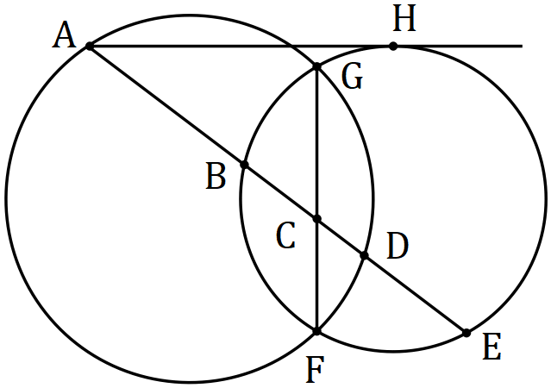

(a) Deduce that $BE=10$. (2 marks)
Solution
$$AH^{2}=AB×AE \\ AE={12}^{2}÷8=18$$

$$BE=AE-AB \\ =18-8=10$$

Specific behaviours
justifies length of $AE$
✓ justifies length of $BE$

(b) Determine $BC$ and $CD$, justifying your answers. (4 marks)
Solution
$$BC×CE=GC×CF$$
$$x=BC$$
$$x\left(10-x\right)=4.5×2=9$$
$$x^{2}-10x+9=0$$
$$\left(x-1\right)\left(x-9\right)=0$$
$$x=BC=1$$

$$AC×CD=GC×CF=9 \\ CD=9÷\left(8+1\right)=1$$

Specific behaviours
justifies equation for $BC$
✓ length of $BC$
✓ justifies equation for $CD$
✓ length of $CD$

Question 8 (8 marks)
(a) Evaluate $\begin{matrix} ^{2020}P_{2} \\ \overline{{101× }^{20}P_{19}}\end{matrix}$. (3 marks)
Solution
$$\begin{matrix} ^{2020}P_{2} \\ \overline{{101× }^{20}P_{1}}\end{matrix}=\frac{2020!}{2018!}÷\left(101×\frac{20!}{19!}\right) \\ =2020×2019÷\left(101×20\right) \\ =2020×2019÷2020 \\ =2019$$

Specific behaviours
expresses as factorials
✓ eliminates factorials
✓ correct value

(b) Given that $^{n+1}P_{r}=k× ^{n}P_{r}$, determine the constant $k$ in terms of $n$ and/or $r$. (3 marks)

Solution
$$^{n+1}P_{r}=\frac{\left(n+1\right)!}{\left(n+1-r\right)!}$$
$$=\frac{\left(n+1\right)n!}{\left(n+1-r\right)\left(n-r\right)!}$$

$$∴k=\frac{n+1}{n+1-r}$$

Specific behaviours
expresses LHS using factorials
✓ factors out term from denominator
✓ correct expression

(c) Given that $^{14}P_{12}=43 589 145 600$, determine $^{16}P_{12}$. (2 marks)
Solution
$$^{16}P_{12}=\frac{16}{4}× ^{15}P_{12}=4×\frac{15}{3}× ^{14}P_{12}=20× ^{14}P_{12}$$

$$20×43 589 145 600=871 782 912 000$$

Specific behaviours
correct multiplier
✓ correct value

Supplementary page

Question number: _________

© 2019 WA Exam Papers. Applecross Senior High School has a non-exclusive licence to copy and communicate this document for non-commercial, educational use within the school. No other copying, communication or use is permitted without the express written permission of WA Exam Papers. SN002-131-2.

